(Suggested Website URL: <https://dxlink.ca/programs/Painting-the-Patient-Journey>)

(Button)

Aide

(Button)

English

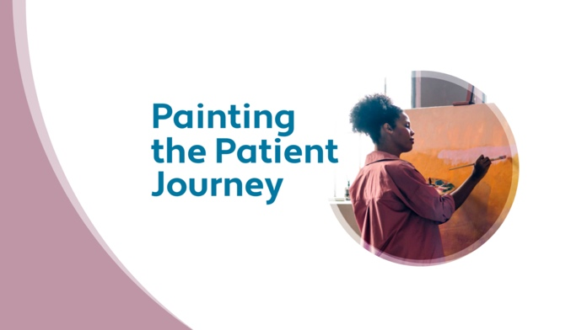

**Program Overview:**

This program is aimed at primary care physicians who are managing patients with type 2 diabetes. It will discuss how to optimize glycemic control using basal insulin and discuss when to intensify therapy.

|  |  |
| --- | --- |
| (Button – DxLink login)  Register | (Button)  Login |

**Scientific Planning Committee:**

(Please leave room for photos and credentials – credentials to be updated)

Dr. Susan Wilkinson – Family Medicine – FMWC Lead

Dr. Amel Arnaout – Family Medicine

Dr. Basel Bari – Family Medicine   
Dr. Marie-Andree Corbeil – Endocrinologist  
Dr. Sonja Reichert – Endocrinologist

**Learning Objectives:**

* Determine the time when to initiate basal insulin and how to optimize this treatment option in type 2 diabetes
* Recognize the different basal insulin options, including biosimilars, and understand when to intensify therapy
* Explain the role of time-in-range measurements to optimize glycemic control and potential role in reducing short and long-term risk in patients with type 2 diabetes using insulin
* Determine candidates and titration of patients on fixed-ratio combination (FRC) basal insulin

|  |  |  |  |
| --- | --- | --- | --- |
| Case 1  **Initiating Insulin in Type 2 Diabetes** | Case 2  **Utilizing Insulin in Older Adults** | Case 3  **The Value of CGM in Managing People with Diabetes Using Insulin** | Case 4  **Intensification Beyond Basal Insulin** |

(Accreditation Statement)

TBD

(Footnotes)

This program was developed and planned by the FMWC to achieve scientific integrity, objectivity, and balance. Sanofi provided an unrestricted educational grant.

(FMWC logo)

[HELP PAGE]

If you would like to get in touch with technical support or the website host, please contact STA HealthCare Communications:

Joelle Miller

Project Coordinator

[joellem@sta.ca](mailto:joellem@sta.ca)

[Menu – Postgate]

Home

Case 1:

Initiating Insulin in Type 2 Diabetes

Case 2:

Utilizing Insulin in Older Adults

Case 3:

The Value of CGM in Managing People with Diabetes Using Insulin

Case 4:

Intensification Beyond Basal Insulin

Evaluation

Certificate

[HOMEPAGE]



**Program Overview:**

This program is aimed at primary care physicians who are managing patients with type 2 diabetes. It will discuss how to optimize glycemic control using basal insulin and discuss when to intensify therapy.

**Scientific Planning Committee:**

(Please leave room for photos and credentials – credentials to be updated)

Dr. Susan Wilkinson – Family Medicine – FMWC Lead

Dr. Amel Arnaout – Family Medicine

Dr. Basel Bari – Family Medicine   
Dr. Marie-Andree Corbeil – Endocrinologist  
Dr. Sonja Reichert – Endocrinologist

**Learning Objectives:**

* Determine the time when to initiate basal insulin and how to optimize this treatment option in type 2 diabetes
* Recognize the different basal insulin options, including biosimilars, and understand when to intensify therapy
* Explain the role of time-in-range measurements to optimize glycemic control and potential role in reducing short and long-term risk in patients with type 2 diabetes using insulin
* Determine candidates and titration of patients on fixed-ratio combination (FRC) basal insulin

|  |  |  |  |
| --- | --- | --- | --- |
| Case 1  **Initiating Insulin in Type 2 Diabetes** | Case 2  **Utilizing Insulin in Older Adults** | Case 3  **The Value of CGM in Managing People with Diabetes Using Insulin** | Case 4  **Intensification Beyond Basal Insulin** |

(Accreditation Statement)

TBD

(Footnotes)

This program was developed and planned by the FMWC to achieve scientific integrity, objectivity, and balance. Sanofi provided an unrestricted educational grant.

(FMWC logo)

[CASE 1]

(Title)

**Case 1: Initiating Insulin in Type 2 Diabetes**

(Insert Video: Bari 1)

(Buttons)

|  |  |
| --- | --- |
| Back | Next |

[CASE 1]

(Title)

**Case 1: Initiating Insulin in Type 2 Diabetes**

(Image: Include image of patient profile)

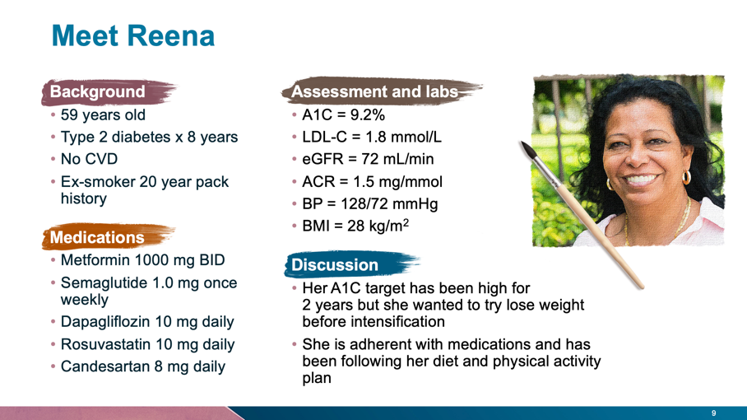

(Copy)

**Interactive Question 1**

**If Reena was your patient, what would be your course of action? (Please check all that apply)**

1. Increase dose of semaglutide to 2.0 mg weekly
2. Intensify diet and physical activity
3. Add sulfonylurea
4. Add pioglitazone
5. Add acarbose
6. Add basal insulin
7. Change semaglutide to fixed-ratio combination (GLP-1 RA/insulin)

**Answer:** (Include peer responses)

There is no ‘right’ answer but the question is to engage thought around what you would do. Dr. Bari will provide additional context in his next video.

(Buttons)

|  |  |
| --- | --- |
| Back | Next |

[CASE 1]

(Title)

**Case 1: Initiating Insulin in Type 2 Diabetes**

(Insert Video: Bari 2)

(Buttons)

|  |  |
| --- | --- |
| Back | Next |

[CASE 1]

(Title)

**Case 1: Initiating Insulin in Type 2 Diabetes**

(Image: Include image of patient profile)

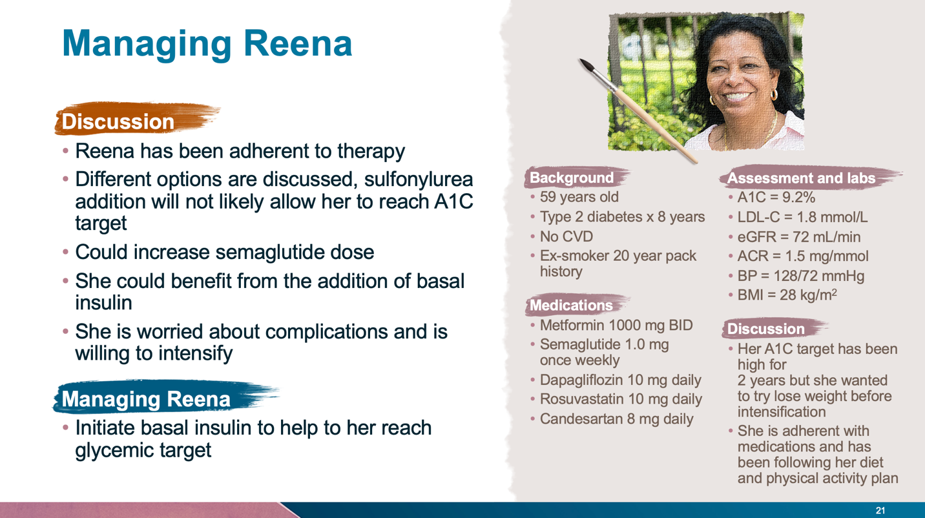

(Copy)

**Interactive Question 2**

**Reena is going to be initiated on basal insulin. Which of the following statements is TRUE?**

1. The starting dose should be 5 units daily
2. 2nd generation basal analogues have a lower risk of hypoglycemia
3. The titration for all basal insulins should be increased daily
4. Target fasting blood glucose should be < 10.0 mmol/L

**Answer:** (Include peer responses)

The correct answer is b), 2nd generation basal analogues have a lower risk of hypoglycemia.

(Buttons)

|  |  |
| --- | --- |
| Back | Next |

[CASE 1]

(Title)

**Case 1: Initiating Insulin in Type 2 Diabetes**

(Insert Video: Bari 3)

(Buttons)

|  |  |
| --- | --- |
| Back | Next |

[CASE 1]

(Title)

**Case 1: Initiating Insulin in Type 2 Diabetes**

(Image: Include image of patient profile)

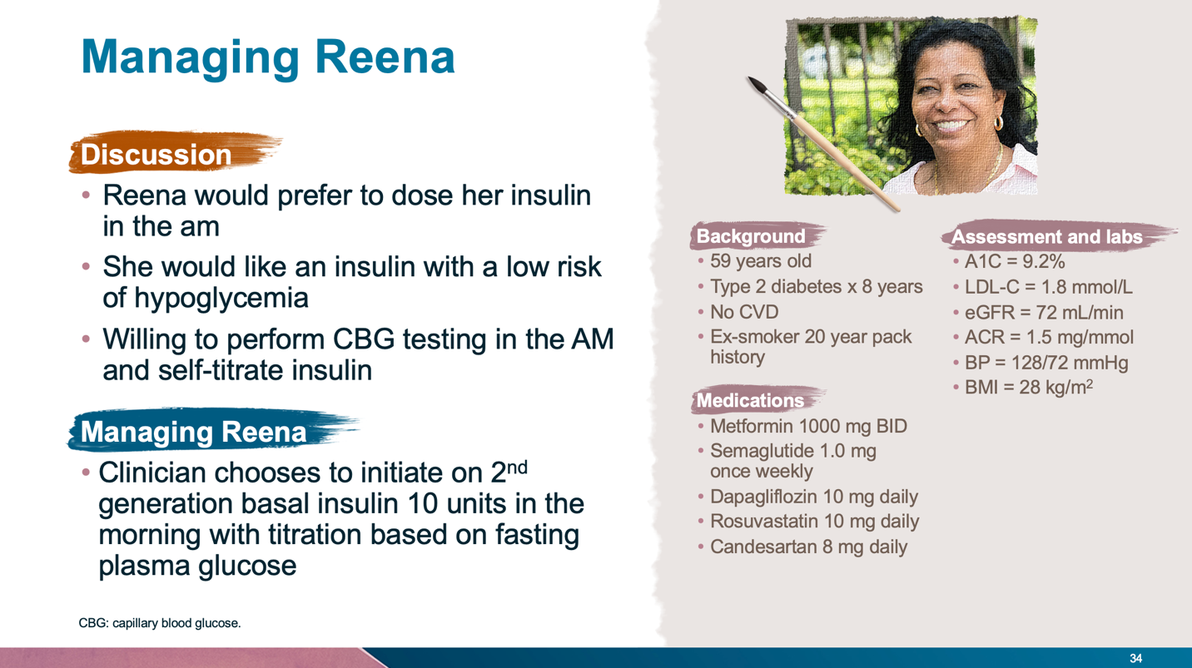

(Copy)

**Interactive Question 3**

**The clinician provides training for patient on basal insulin. Which of the following statements is TRUE?**

* 1. Insulin pen devices should be primed every time before dosing
  2. She must use an alcohol swab on the insulin pen cartridge and on the injection site
  3. 8 mm pen is preferred for most patients with overweight or obesity
  4. It is important that she pinch prior to injection

**Answer:** (Include peer responses)

The correct answer is a), insulin pen devices should be primed every time before dosing.

(Buttons)

|  |  |
| --- | --- |
| Back | Next |

[CASE 1]

(Title)

**Case 1: Initiating Insulin in Type 2 Diabetes**

(Insert Video: Bari 4)

(Buttons)

|  |  |
| --- | --- |
| Back | Next |

[CASE 1]

(Title)

**Case 1: Initiating Insulin in Type 2 Diabetes**

(Image: Include image of patient profile)

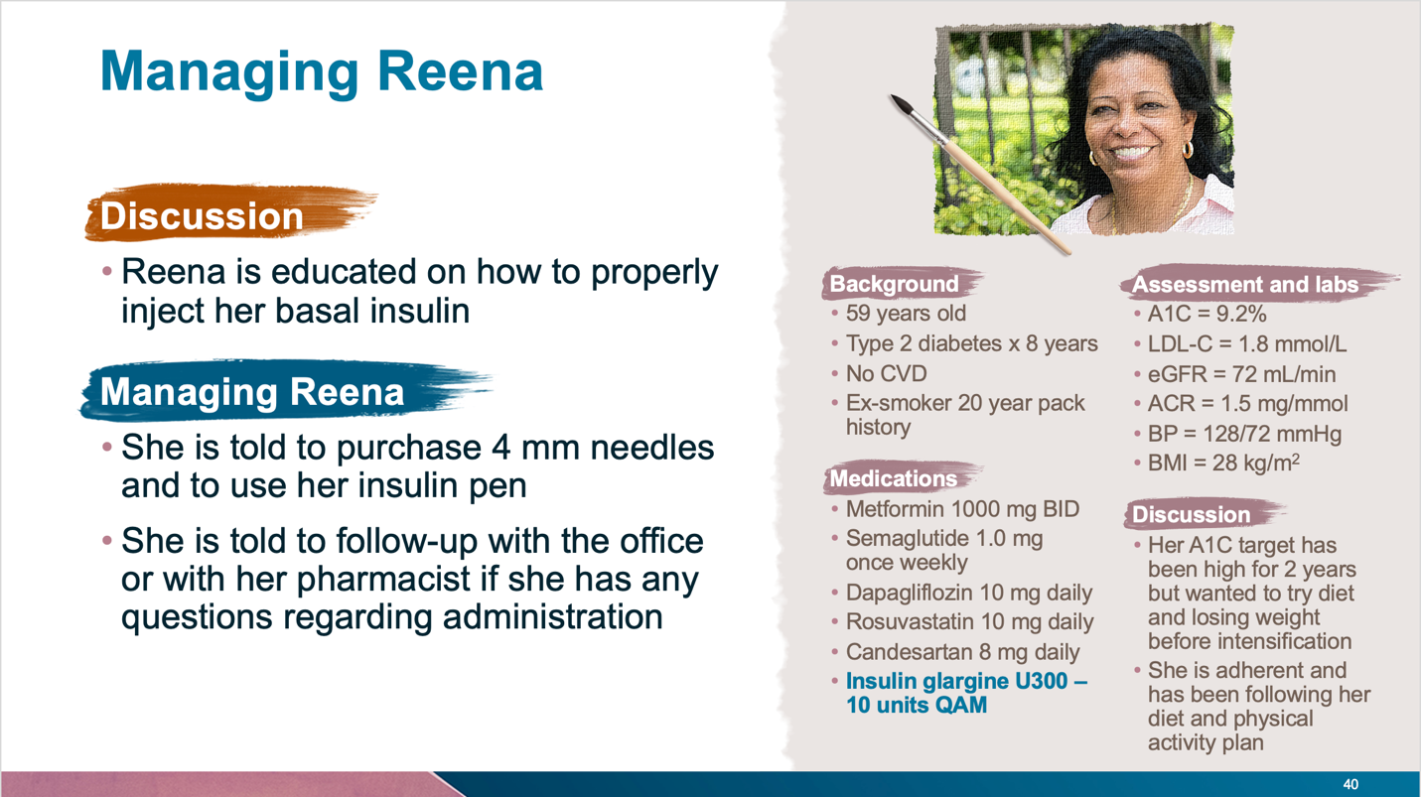

(Copy)

**Interactive Question 4**

**Reena is in to see her clinician 4 months later. She titrated her insulin, but she is still not reaching A1C target. What would be your course of action? (Please check all that apply)**

* 1. Increase insulin glargine dose
  2. Increase semaglutide dose
  3. Reassess injection technique
  4. Add prandial insulin

**Answer:** (Include peer responses)

The correct answers are a) and c), increase insulin glargine dose and reassess injection technique.

(Buttons)

|  |  |
| --- | --- |
| Back | Next |

[CASE 1]

(Title)

**Case 1: Initiating Insulin in Type 2 Diabetes**

(Insert Video: Bari 5)

(Buttons)

|  |  |
| --- | --- |
| Back | Next |

[CASE 2]

**Case 2: Utilizing Insulin in Older Adults**

(Insert Video: Arnaout 1)

(Buttons)

|  |  |
| --- | --- |
| Back | Next |

[CASE 2]

(Title)

**Case 2: Utilizing Insulin in Older Adults**

(Image: Include image of patient profile)

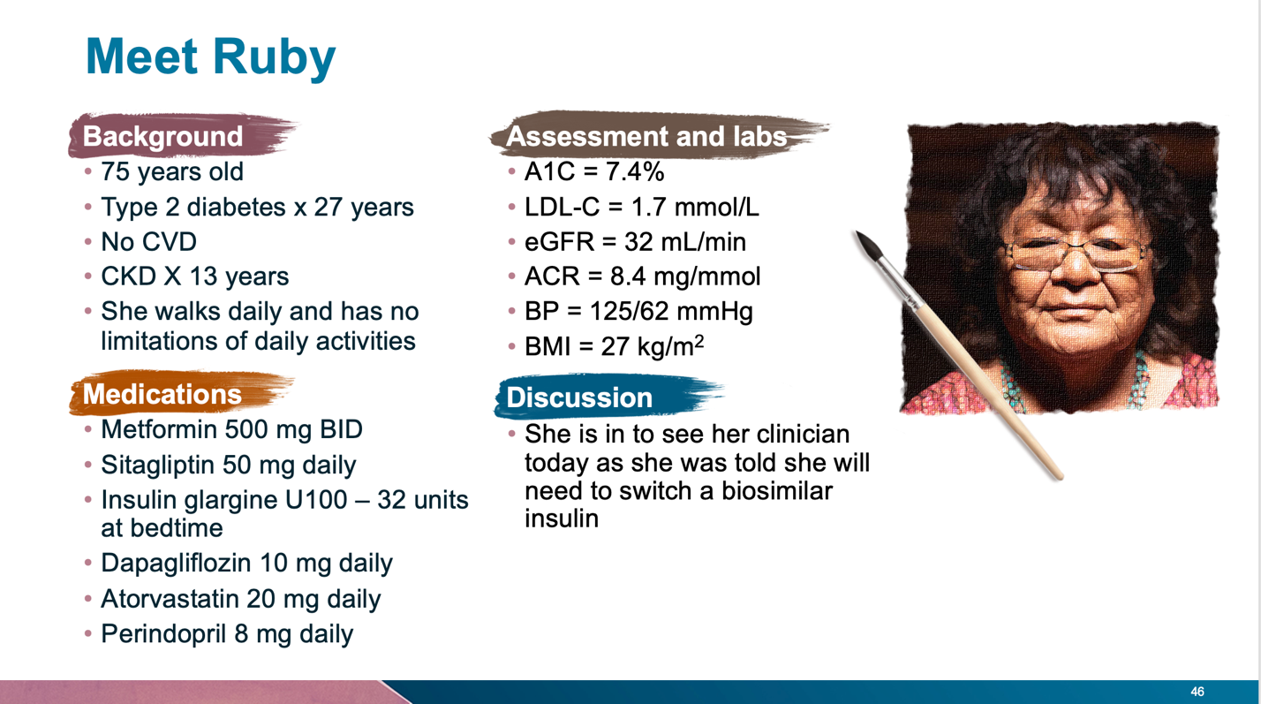

(Copy)

**Interactive Question 1**

**If Ruby was your patient, what A1C target would you set?**

1. ≤ 6.5%
2. ≤ 7.0%
3. ≤ 8.0%
4. ≤ 8.5%

**Answer:** (Include peer responses)

The correct answer is b), ≤ 7.0%.

(Buttons)

|  |  |
| --- | --- |
| Back | Next |

[CASE 2]

**Case 2: Utilizing Insulin in Older Adults**

(Insert Video: Arnaout 2)

(Buttons)

|  |  |
| --- | --- |
| Back | Next |

[CASE 2]

(Title)

**Case 2: Utilizing Insulin in Older Adults**

(Image: Include image of patient profile)

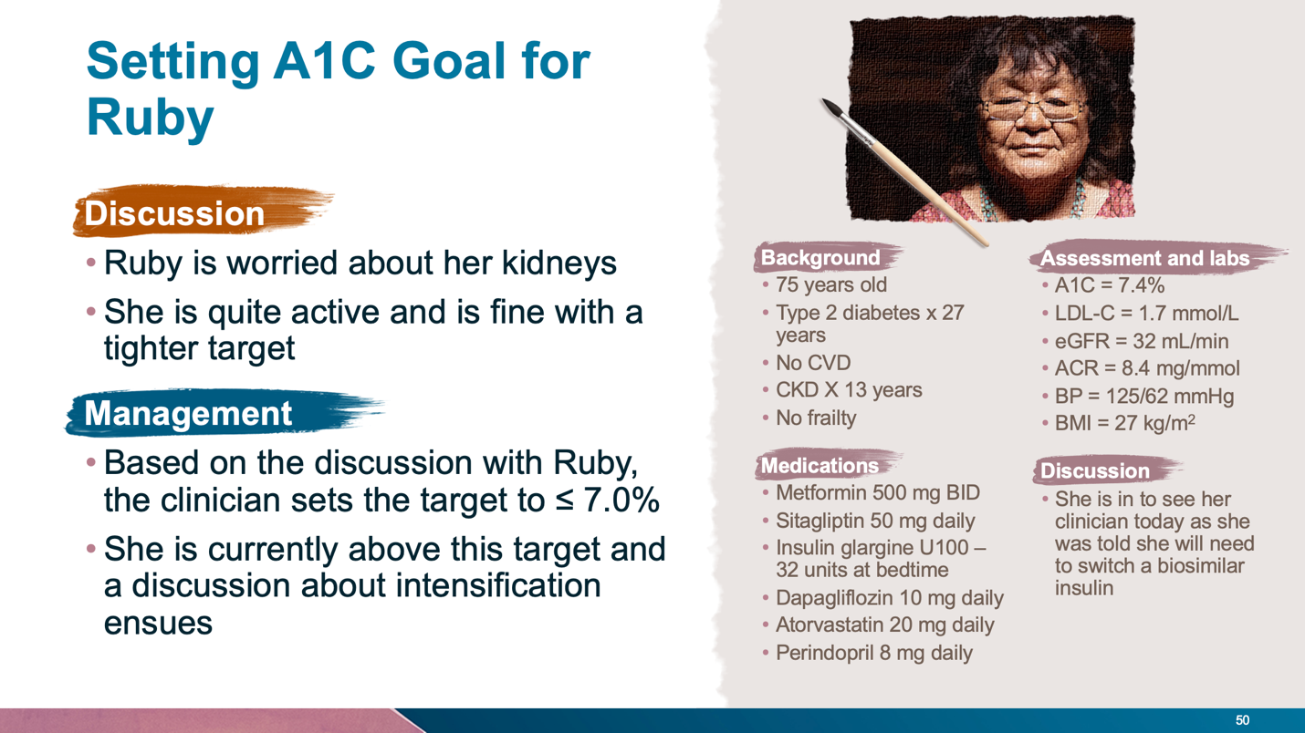

(Copy)

**Interactive Question 2**

**Ruby has a brother and sister with type 2 diabetes and she is the only one using insulin. She wants to know if insulin should be used in seniors. Which of the following statements is TRUE?**

1. The risk of basal insulin in older adults exceeds the benefits
2. Generally, a higher A1C target is preferred over using insulin in older adults
3. Insulin is an effective and safe option in older adults
4. Insulin in the preferred 2nd line agent in older adults with CKD

**Answer:** (Include peer responses)

The correct answer is c), insulin is an effective and safe option in older adults.

(Buttons)

|  |  |
| --- | --- |
| Back | Next |

[CASE 2]

**Case 2: Utilizing Insulin in Older Adults**

(Insert Video: Arnaout 3)

(Buttons)

|  |  |
| --- | --- |
| Back | Next |

[CASE 2]

(Title)

**Case 2: Utilizing Insulin in Older Adults**

(Image: Include image of patient profile)

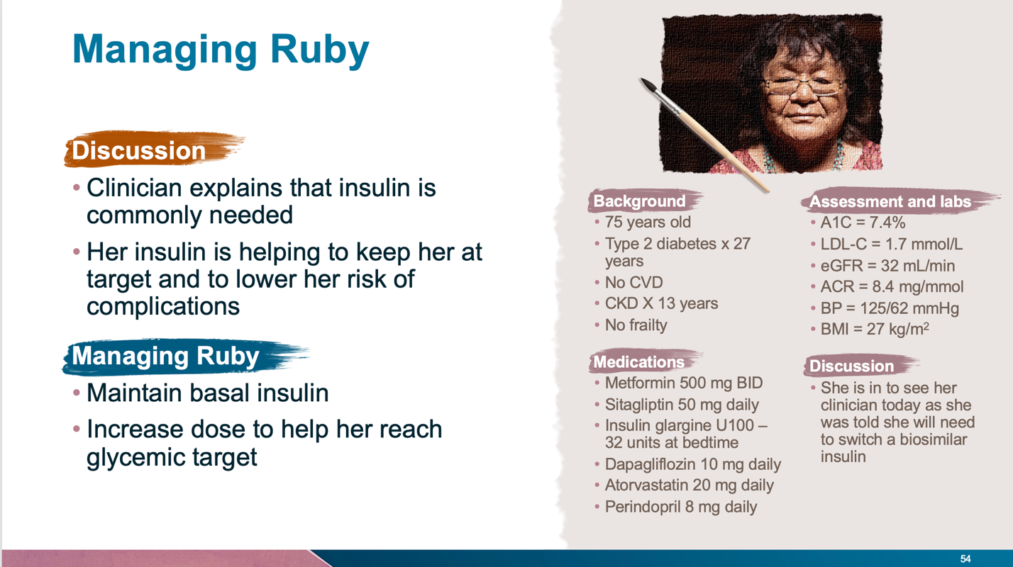

(Copy)

**Interactive Question 3**

**How would you manage the question regarding the switch to a biosimilar insulin?**

1. Switch to the biosimilar insulin
2. Switch to a 2nd generation basal insulin
3. I would tell her to stay on her current insulin and pay the difference
4. I would prescribe whatever basal insulin is covered

**Answer:** (Include peer responses)

There is no right or wrong answer here. The purpose is to engage the thought process to start thinking about best way to manage this patient.

(Buttons)

|  |  |
| --- | --- |
| Back | Next |

[CASE 2]

**Case 2: Utilizing Insulin in Older Adults**

(Insert Video: Arnaout 4)

(Buttons)

|  |  |
| --- | --- |
| Back | Next |

[CASE 2]

(Title)

**Case 2: Utilizing Insulin in Older Adults**

(Image: Include image of patient profile)

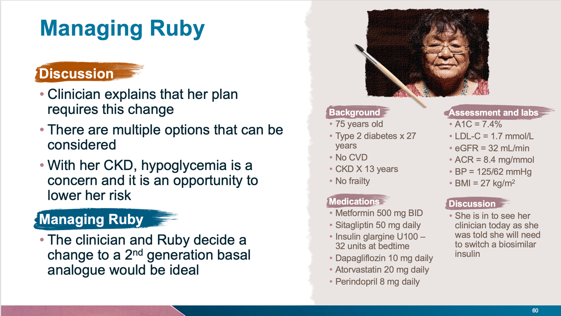

(Copy)

**Interactive Question 4**

**How would you switch Mary from her current insulin to a 2nd generation basal insulin analogue? (Please check all that apply)**

1. Reduce her dose by 20% and administer at the same time
2. Switch to 2nd generation at the same dose
3. Ensure she is monitoring her glucose daily
4. Provide training on the new pen and administration

**Answer:** (Include peer responses)

The correct answers are b), c) and d), the patient should switch to a 2nd generation at the same dose, while the physician ensures that she is monitoring her glucose daily and provides training on the new pen and administration.

(Buttons)

|  |  |
| --- | --- |
| Back | Next |

[CASE 2]

**Case 2: Utilizing Insulin in Older Adults**

(Insert Video: Arnaout 5)

(Buttons)

|  |  |
| --- | --- |
| Back | Next |

[CASE 3]

**Case 3: The Value of CGM in Managing People with Diabetes Using Insulin**

(Insert Video: Arnaout 6)

(Buttons)

|  |  |
| --- | --- |
| Back | Next |

[CASE 3]

(Title)

**Case 3: The Value of CGM in Managing People with Diabetes Using Insulin**

(Image: Include image of patient profile)

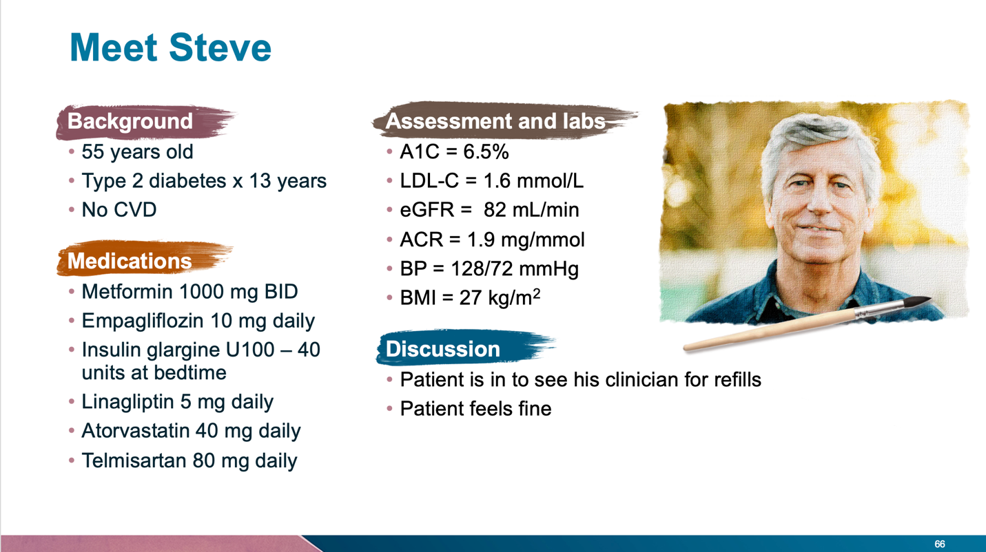

(Copy)

**Interactive Question 1**

**If Steve was your patient what would be your course of action? (Please check all that apply)**

1. No changes at this time
2. Reduce dose of insulin glargine
3. Screen for hypoglycemia
4. Discontinue linagliptin

**Answer:** (Include peer responses)

The correct answer is c), screen for hypoglycemia.

(Buttons)

|  |  |
| --- | --- |
| Back | Next |

[CASE 3]

**Case 3: The Value of CGM in Managing People with Diabetes Using Insulin**

(Insert Video: Arnaout 7)

(Buttons)

|  |  |
| --- | --- |
| Back | Next |

[CASE 3]

(Title)

**Case 3: The Value of CGM in Managing People with Diabetes Using Insulin**

(Image: Include image of patient profile)

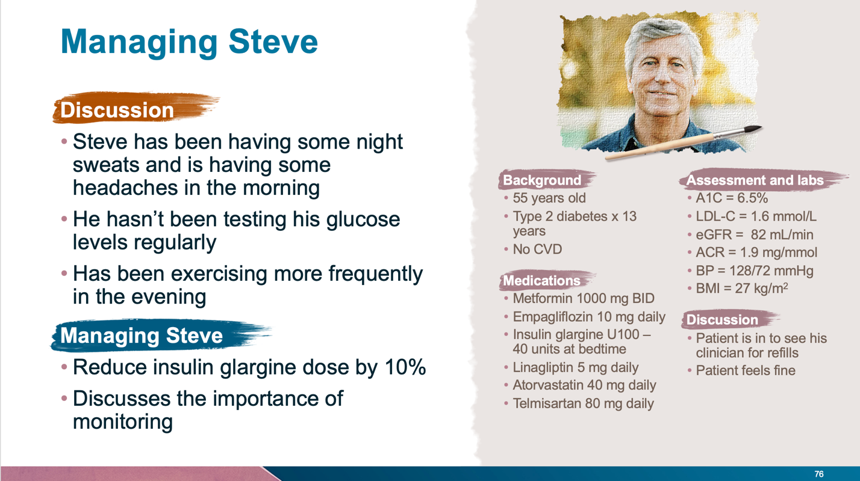

(Copy)

**Interactive Question 2**

**Steve mentions that his current blood glucose meter is old. He wants to know if he would be a candidate for a continuous glucose monitoring (CGM). Would you consider CGM for this patient?**

1. Yes
2. No

**Answer:** (Include peer responses)

This patient is a candidate for CGM. The purpose was to poll physicians to see how they would respond.

(Buttons)

|  |  |
| --- | --- |
| Back | Next |

[CASE 3]

**Case 3: The Value of CGM in Managing People with Diabetes Using Insulin**

(Insert Video: Arnaout 8)

(Buttons)

|  |  |
| --- | --- |
| Back | Next |

[CASE 3]

(Title)

**Case 3: The Value of CGM in Managing People with Diabetes Using Insulin**

(Image: Include image of patient profile)

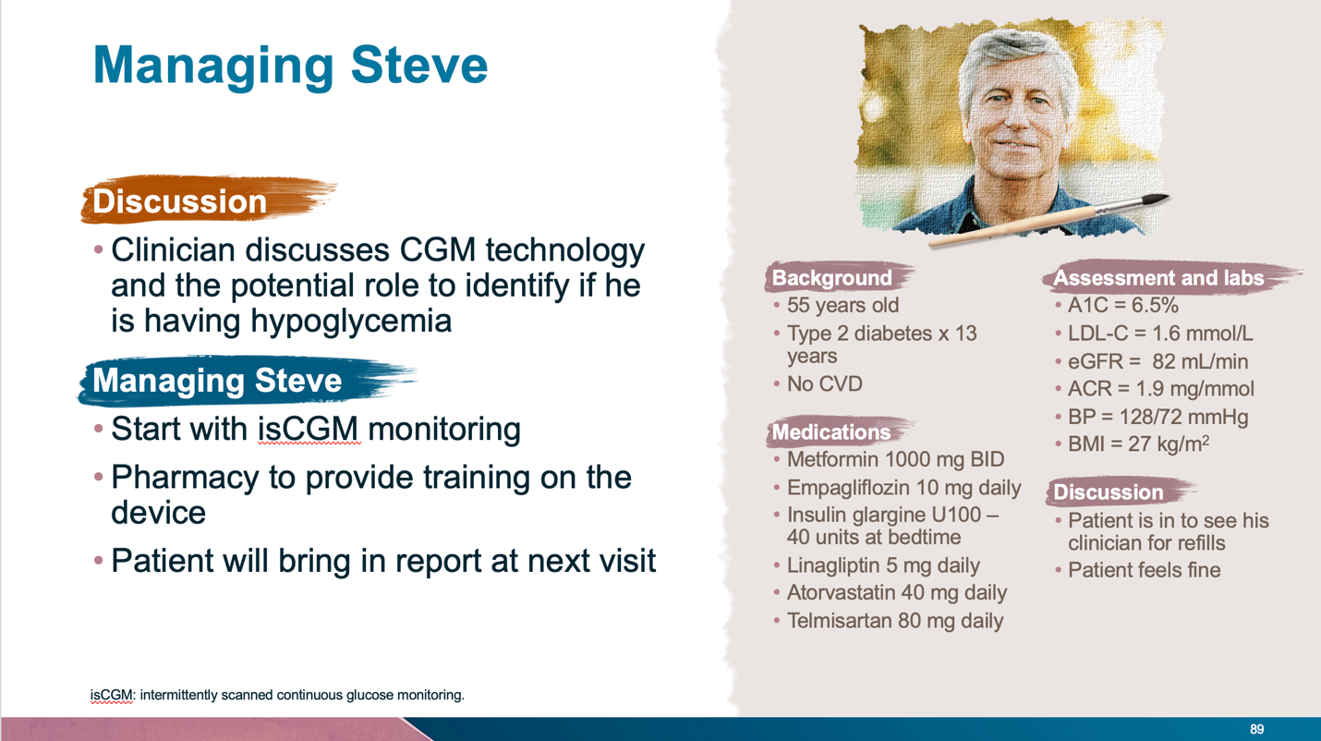

(Copy)

**Interactive Question 3**

**Steve wants to know the significance of glycemic variability. Which of the following statements is TRUE? (please check all that apply)**

1. It is only a marker for hypoglycemia risk
2. It is rarely an issue in patients taking insulin
3. The target is < 20%
4. It is correlated with time-in-range

**Answer:** (Include peer responses)

The correct answer is d), it is correlated with time-in-range.

(Buttons)

|  |  |
| --- | --- |
| Back | Next |

[CASE 3]

**Case 3: The Value of CGM in Managing People with Diabetes Using Insulin**

(Insert Video: Arnaout 9)

(Buttons)

|  |  |
| --- | --- |
| Back | Next |

[CASE 3]

(Title)

**Case 3: The Value of CGM in Managing People with Diabetes Using Insulin**

(Image: Include image of patient profile)

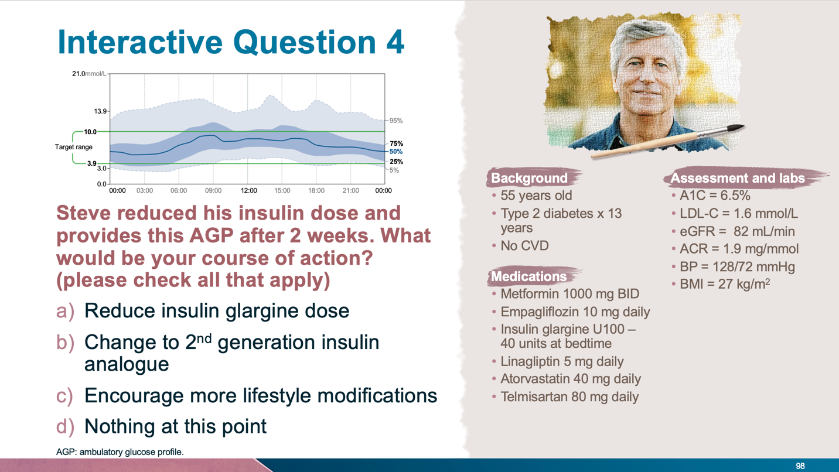

(Copy)

**Interactive Question 4**

**Steve reduced his insulin dose and provides this AGP after 2 weeks. What would be your course of action? (please check all that apply)**

1. Reduce insulin glargine dose
2. Change to 2nd generation insulin analogue
3. Encourage more lifestyle modifications
4. Nothing at this point

**Answer:** (Include peer responses)

The correct answers are a) and b). The correct course of action for Steve would be to reduce his insulin glargine dose and to change him to a 2nd generation insulin analogue.

(Buttons)

|  |  |
| --- | --- |
| Back | Next |

[CASE 3]

**Case 3: The Value of CGM in Managing People with Diabetes Using Insulin**

(Insert Video: Arnaout 10)

(Buttons)

|  |  |
| --- | --- |
| Back | Next |

[CASE 4]

**Case 4: Intensification Beyond Basal Insulin**

(Insert Video: Reichert 1)

(Buttons)

|  |  |
| --- | --- |
| Back | Next |

[CASE 4]

(Title)

**Case 4: Intensification Beyond Basal Insulin**

(Image: Include image of patient profile)

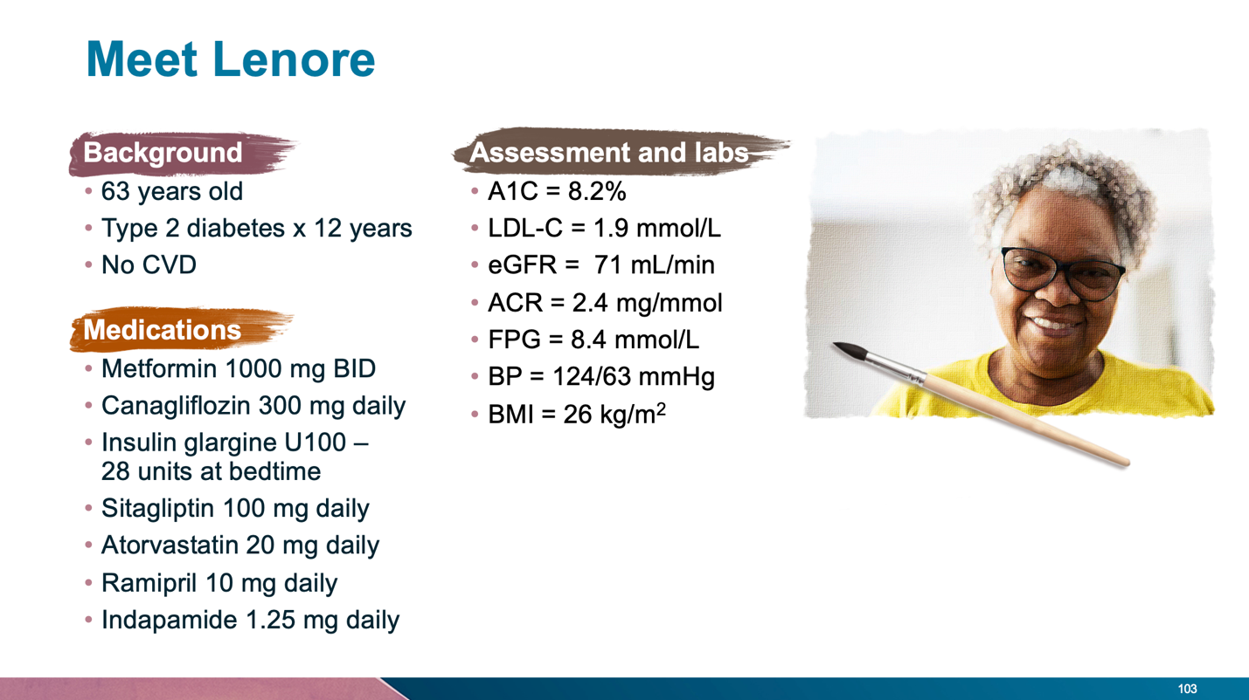

(Copy)

**Interactive Question 1**

**If Lenore was your patient what would be your course of action? (Please check all that apply)**

1. Increase insulin glargine dose
2. Change DPP4i to GLP-1 RA
3. Add prandial insulin
4. Add sulfonylurea

**Answer:** (Include peer responses)

The correct answer is a), increase insulin glargine dose.

(Buttons)

|  |  |
| --- | --- |
| Back | Next |

[CASE 4]

**Case 4: Intensification Beyond Basal Insulin**

(Insert Video: Reichert 2)

(Buttons)

|  |  |
| --- | --- |
| Back | Next |

[CASE 4]

(Title)

**Case 4: Intensification Beyond Basal Insulin**

(Image: Include image of patient profile)

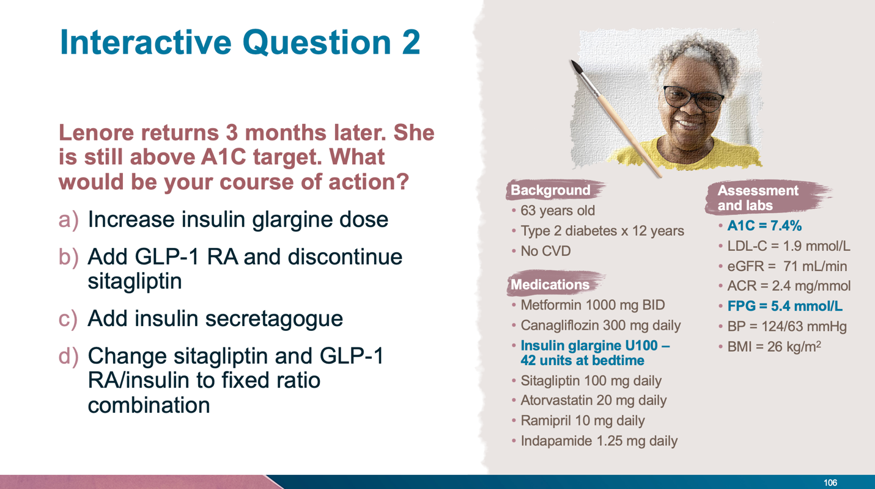

(Copy)

**Interactive Question 2**

**Lenore returns 3 months later. She is still above A1C target. What would be your course of action?**

1. Increase insulin glargine dose
2. Add GLP-1 RA and discontinue sitagliptin
3. Add insulin secretagogue
4. Change sitagliptin and GLP-1 RA/insulin to fixed ratio combination

**Answer:** (Include peer responses)

The correct answers are b) and d), add GLP-1 RA and discontinue sitagliptin and change sitagliptin and GLP-1 RA/insulin to fixed dose combination.

(Buttons)

|  |  |
| --- | --- |
| Back | Next |

[CASE 4]

**Case 4: Intensification Beyond Basal Insulin**

(Insert Video: Reichert 3)

(Buttons)

|  |  |
| --- | --- |
| Back | Next |

[CASE 4]

(Title)

**Case 4: Intensification Beyond Basal Insulin**

(Image: Include image of patient profile)

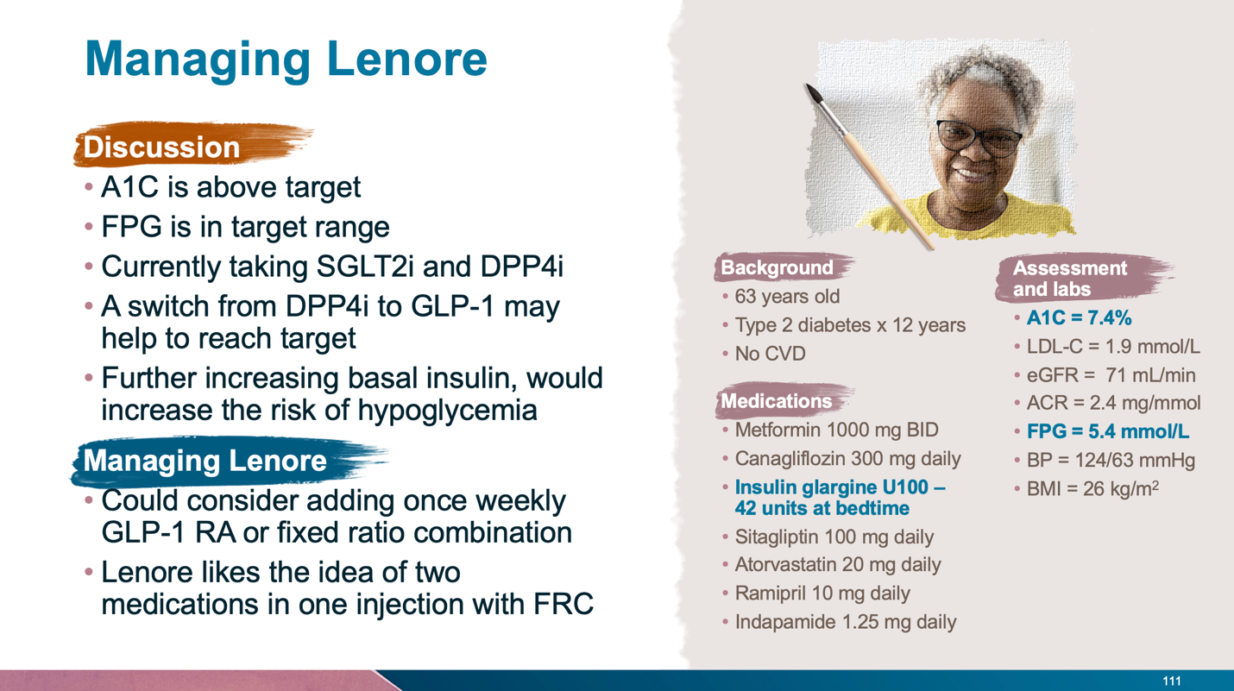

(Copy)

**Interactive Question 3**

**Lenore is interested in trying the FRC. She is being considered for insulin glargine and lixisenatide fixed ratio combination. What dose would she start on?**

1. 15 units
2. 30 units
3. 42 units
4. 60 units

**Answer:** (Include peer responses)

The correct answer is b), 30 units.

(Buttons)

|  |  |
| --- | --- |
| Back | Next |

[CASE 4]

**Case 4: Intensification Beyond Basal Insulin**

(Insert Video: Reichert 4)

(Buttons)

|  |  |
| --- | --- |
| Back | Next |

[CASE 4]

(Title)

**Case 4: Intensification Beyond Basal Insulin**

(Image: Include image of patient profile)

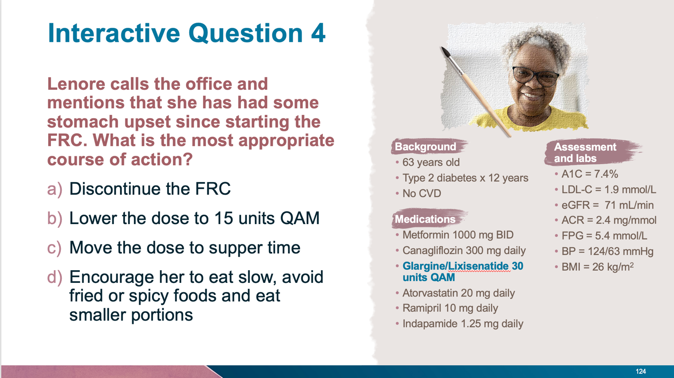

(Copy)

**Interactive Question 4**

**Lenore calls the office and mentions that she has had some stomach upset since starting the FRC. What is the most appropriate course of action?**

1. Discontinue the FRC
2. Lower the dose to 15 units QAM
3. Move the dose to supper time
4. Encourage her to eat slow, avoid fried or spicy foods and eat smaller portions

**Answer:** (Include peer responses)

The correct answer is d), provide the patient with some suggestions that may help her upset stomach, including: encouraging her to eat slow, avoid fried or spicy foods and to eat smaller portions.

(Buttons)

|  |  |
| --- | --- |
| Back | Next |

[CASE 4]

**Case 4: Intensification Beyond Basal Insulin**

(Insert Video: Reichert 5)

(Buttons)

|  |  |
| --- | --- |
| Back | Next |

[EVALUATION]

**Evaluation**

Please indicate your profession:

 Family Physician  General Practitioner  Nurse  Other

Please indicate the degree to which you agree with the statements below, using the following scale:

1 Strongly agree; 2 Agree; 3 Neutral; 4 Disagree; 5 Strongly disagree

**The Program**

This program content enhanced my knowledge

The program was relevant to me

The program met the stated learning objectives

Updates discussed in the program will impact my practice

The format was effective

This activity was of value to me in my current role

The program was well-organized

The program was unbiased

**The Speakers**

**Dr. Bari**

Presented the program clearly and effectively

Demonstrated good leadership qualities

**Dr. Arnaout**

Presented the program clearly and effectively

Demonstrated good leadership qualities

**Dr. Reichert**

Presented the program clearly and effectively

Demonstrated good leadership qualities

Please answer the following questions:

1. How likely would you be to recommend this program to a friend or colleague?

Not all all likely

0

Extremely likely

10

(image)

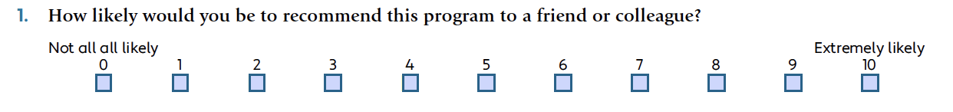

2. Describe two positive features of this program:

1.

2.

3. Would you change anything about the program?  Yes  No

*If so, please explain.*

4. What did you learn from this program that you plan to use in your practice?

5. Please list any other related topics that you would like to see covered in future learning programs:

6. Are there any gaps in care or other challenges that you would like to discuss?

7. Did you perceive any degree of bias in any part of the program?  Yes  No

*If yes, please describe.*

8. Did the activity respect the CQDPCM Code of Ethics (http://cqdpcm.ca)?  Yes  No

9. General comments and suggestions:

[CERTIFICATE]

**Certificate**

To be issued a Certificate of Participation for accreditation purposes, you must complete:

* A case:
  + Watch Case 1, Case 2, Case 3, or Case 4 videos
  + Complete the associated interactive questions
* Evaluation
* Please note, you will receive credits based on the number of cases that you complete (1 case = 0.5 hours of credits)

Upon completion you can then click on “Certificate” to see your personalized certificate which you can download or print and save for your records.

(Button)

Certificate

Progress tracker:

Case completion

**Case 1**

|  |  |  |  |  |
| --- | --- | --- | --- | --- |
|  | Q1 | Q2 | Q3 | Q4 |
| Completion Status |  |  |  |  |

**Case 2**

|  |  |  |  |  |
| --- | --- | --- | --- | --- |
|  | Q1 | Q2 | Q3 | Q4 |
| Completion Status |  |  |  |  |

**Case 3**

|  |  |  |  |  |
| --- | --- | --- | --- | --- |
|  | Q1 | Q2 | Q3 | Q4 |
| Completion Status |  |  |  |  |

**Case 4**

|  |  |  |  |  |
| --- | --- | --- | --- | --- |
|  | Q1 | Q2 | Q3 | Q4 |
| Completion Status |  |  |  |  |

**Evaluation Form**

|  |  |
| --- | --- |
|  | Evaluation |
| Completion Status |  |